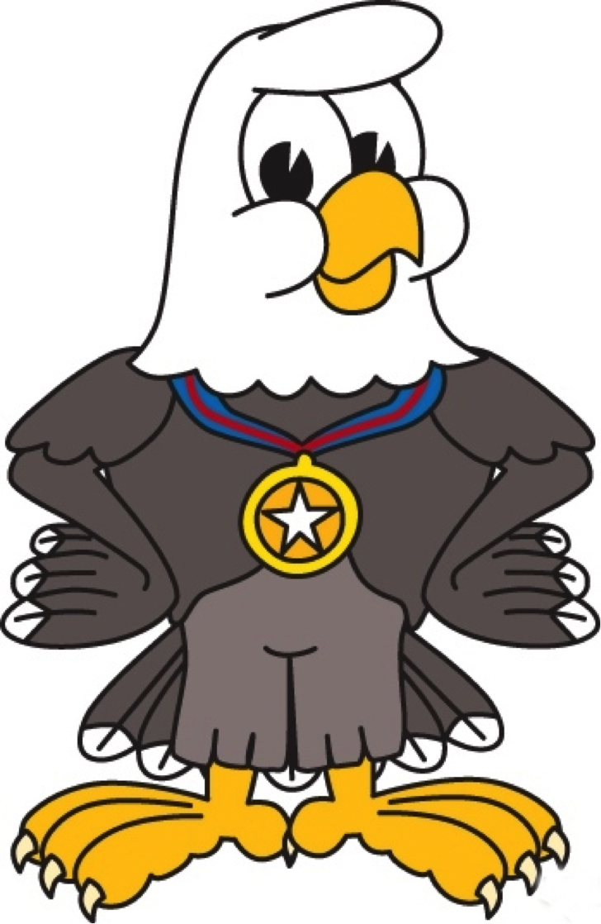**James Monroe Elementary School**

Back To School Supply List

|  |  |  |
| --- | --- | --- |
| **Kindergarten**   * Backpack without wheels (labeled) * 2 composition style) * 10-12 pencils in yellow * 4 large erasers * 8 glue sticks * 3 boxes of tissues * large container disinfecting wipes * 2 full size bottles of hand sanitizer * 3 dry erase markers * Ziploc bags-small and large * Index cards * 1 glue bottle- white * 2 boxes of crayons (24 pack) * 1 pair scissors | **1st Grade**   * 4 Pink Pearl erasers * 2 plastic pencil boxes * 2 boxes of tissues * 2 full size bottles of hand sanitizer * 6 glue sticks * 2 boxes of crayons (24 pack) * 2 packages of pencils (12 pack) * 1 pair scissors | **2nd Grade**   * Dry erase markers * 5 composition notebooks * 2 boxes of crayons (24 pack) * 1 pair scissors * 4 packages of pencils (12 pack) * 6 glue sticks * Colored pencils * 1 ruler- inches and centimeters (wood preferred) * 4 large erasers * highlighters * 2 full size bottles of liquid hand sanitizer * 4 boxes of tissues * 1 container of Clorox or Lysol wipes |
| **3rd Grade**   * 1 Pencil box/pouch * 4 packages of pencils (12 pack) * 1 pair scissors * 2 packs of wide-ruler paper * 4 glue sticks * 1 3-pack of dry erase markers * 2 pocket folders with metal prongs * 1 package of pink erasers * 1 package of permanent markers * 2 full size bottles of liquid hand sanitizer * Water bottle (refillable) | **4th Grade**   * 1 binder 1.5 inch * Dividers * Dry erase markers * Sticky notes * Ziploc bags * 5 packages of wide ruled loose-   leaf paper   * 4 packages of #2 pencils (12 pack) * colored pencils (24 ct) * 6 glue sticks * 4 boxes of tissues * 3 ring pencil storage bag * headphones * 2 highlighters * 3 packages of 3x5 index cards | **5th Grade**   * Dividers * Ziploc bags gallon (boys) * Ziploc bags sandwich (girls) * 2 packages of wide ruled loose- leaf paper, 150 sheets * 5 pocket folders without prong assorted solid colors * 4 packages of #2 yellow pencils (12 pack) * 1 box of colored pencils, pre-sharpened (12 ct) * Ear buds * 1 package of washable markers- broad line, 10 basic colors * Expo dry erase markers * 4 glue sticks * boxes of tissues * Water Bottle (refillable) |
| **Pre-K**   * 2 boxes of tissues * 2 bottles of hand soap * 2 bottles of hand sanitizer * 2 containers of baby wipes * 2 rolls of paper towels * 1 blanket for naptime (labeled) * 1 full-set of emergency clothing * 1 backpack without wheels (labeled) * 2 gallon size, quart size, sandwich size and snack size boxes of Ziploc bags * A jacket or sweater to leave at school | Thank you for ensuring all school supplies are purchased for your scholar. We look forward to a great year of teaching and learning! Also, please keep in mind that these supplies will not last the entire school year. | |